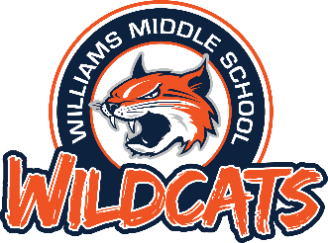 Williams Middle School

Important Dates/Information

- Cheer Mandatory Interest Meetings-February 12th or February 15th, 6:00 PM WMS Library
- Cheer Clinic-February 19-23, 4:30-6:30 PM WMS Gym
- Cheer Fitting-March 26th, 4:30 PM WMS Room B130
- Drill Team Mandatory Parent Meeting-February 22nd, 6:00 PM, WMS Library
- Drill Team Tryout Clinic-March 4th & 6th, 4:00-6:00 PM, WMS Gym
- Drill Team Try-Out-March 7th, WMS Gym
- Mandatory Drill Team fitting-March 20th, 4:30-6:00 PM WMS Library
- Girls Gymnastics Tryouts-April 23rd, 4:30-5:30, WMS Gymnastics Gym
- Boys Gymnastics Tryouts-May 8th, 4:30-5:30, WMS Gymnastics Gym

